**JAVA TEST -1**

**1.sum of Fibonacci series**

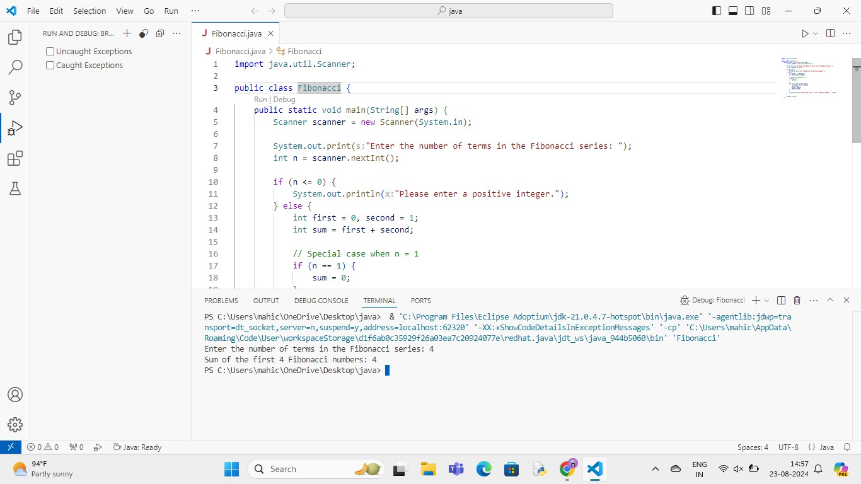

**2.Matric Addition**

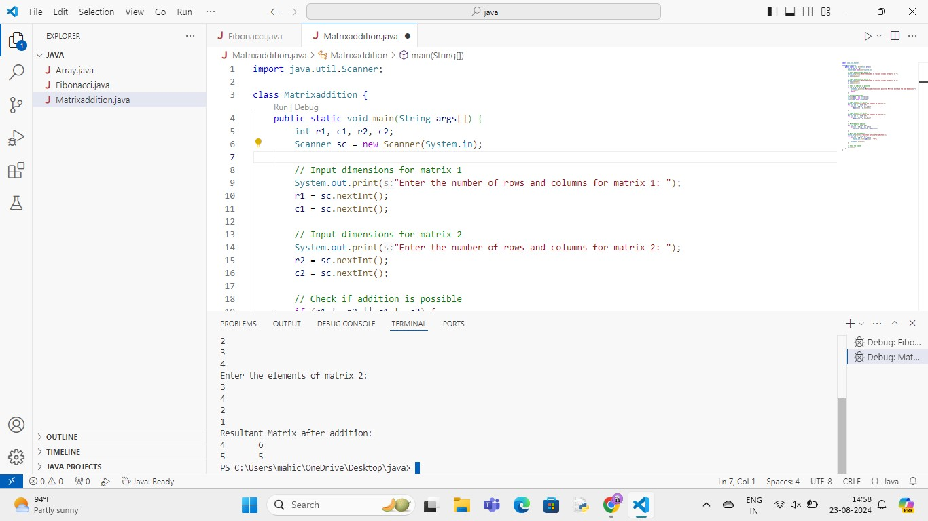

**3.Inverted triangle – pattern**

